

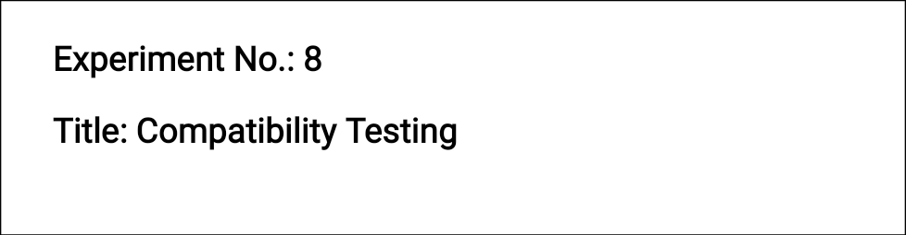

**Batch: B1 Roll No.: 1914078 Experiment No.:8 Aim:** To perform compatibility testing using any open source tool



**Resources needed:** Internet



# Theory:

Compatibility Testing is a type of Software testing to check whether your software is capable of running on different hardware, operating systems, applications, network environments or [Mobile](https://www.guru99.com/mobile-testing.html) devices.

# Types of Compatibility Tests:

**Hardware:** It checks software to be compatible with different hardware configurations.

**Operating Systems:** It checks your software to be compatible with different Operating Systems like Windows, Unix, Mac OS etc.

**Software:** It checks your developed software to be compatible with other softwares. For example: MS Word application should be compatible with other software like MS Outlook, MS Excel, etc.

**Network:** Evaluation of performance of system in a network with varying parameters such as Bandwidth, Operating speed, Capacity. It also checks application in different networks with all parameters mentioned earlier.

**Browser:** It checks compatibility of your website with different browsers like Firefox, Google Chrome and Internet Explorer etc.

**Devices:** It checks compatibility of your software with different devices like USB port Devices, Printers and Scanners, Other media devices and Bluetooth.

**Mobile:** Checking your software is compatible with mobile platforms like Android , iOS etc.

**Versions of the software:** It is verifying software application to be compatible with different versions of software.

The most important use of compatibility testing is to ensure whether developed software works under different configurations (as stated in requirements documentation). This testing is necessary to check whether the application is compatible with client's environment.

Following are the tools which are useful in compatibility testing:

* CrossBrowserTesting
* LambdaTest
* Sauce Labs
* Endtest



# Procedure:

1. Explore any one tool for compatibility testing.
2. Perform compatibility testing of any website.
3. Execute any three features of the tool.



# Results: Snapshots of test results and script

**Lambda Testing**

Go to <https://www.lambdatest.com/> and Signup to use LambdaTest by entering your Email ID and other details.

After successfully signing in, a dashboard appears. Select “Live Test” from the options to carry out Compatibility Testing on the website of our choice.

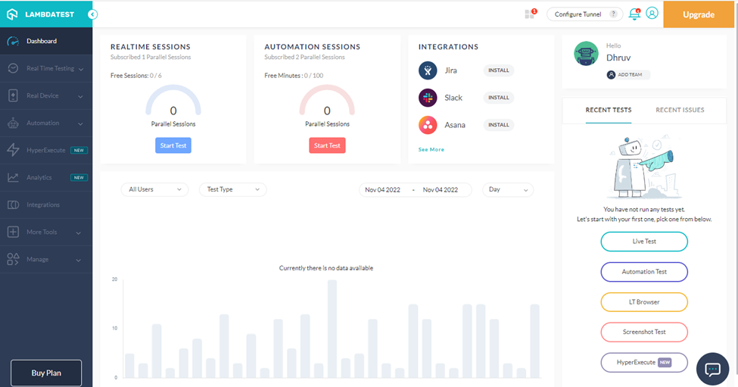

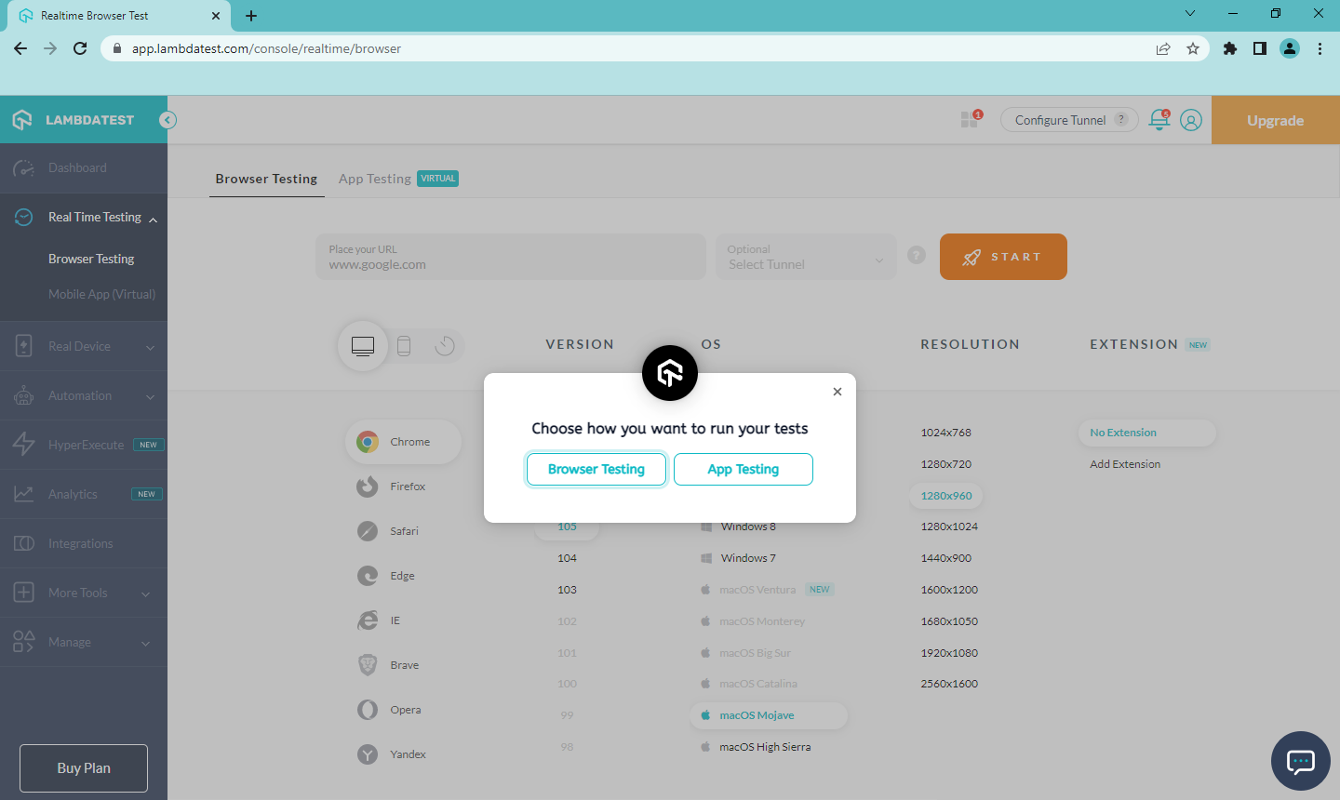

After choosing “Live Test”, we have an option to carry out Browser testing or App Testing. Inside each, we can choose from a number of options in device type, Browser and its version, OS, resolution etc. Start by entering the URL of the website to be tested and the choice of browser and OS in Browser testing.

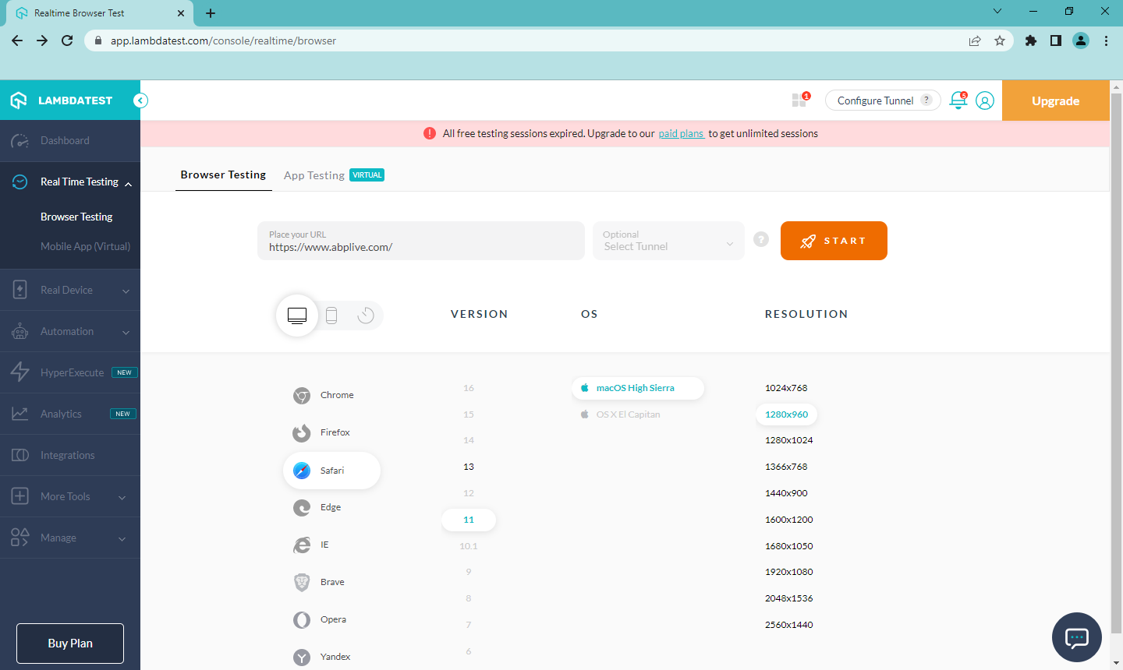

Checking the website https://www.abplive.com/ for the following combinations

Session 1:

Device - Desktop

Browser – Chrome (version 105)

OS – MacOS Mojave

Resolution – 1280 X 960

Session Details:

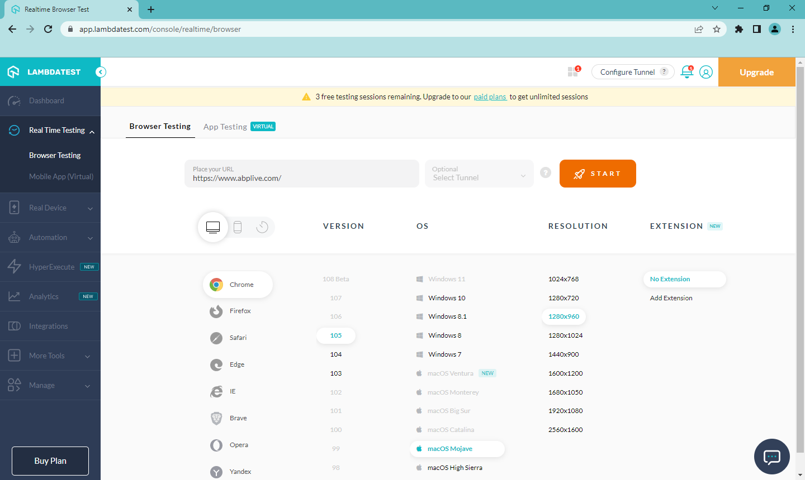

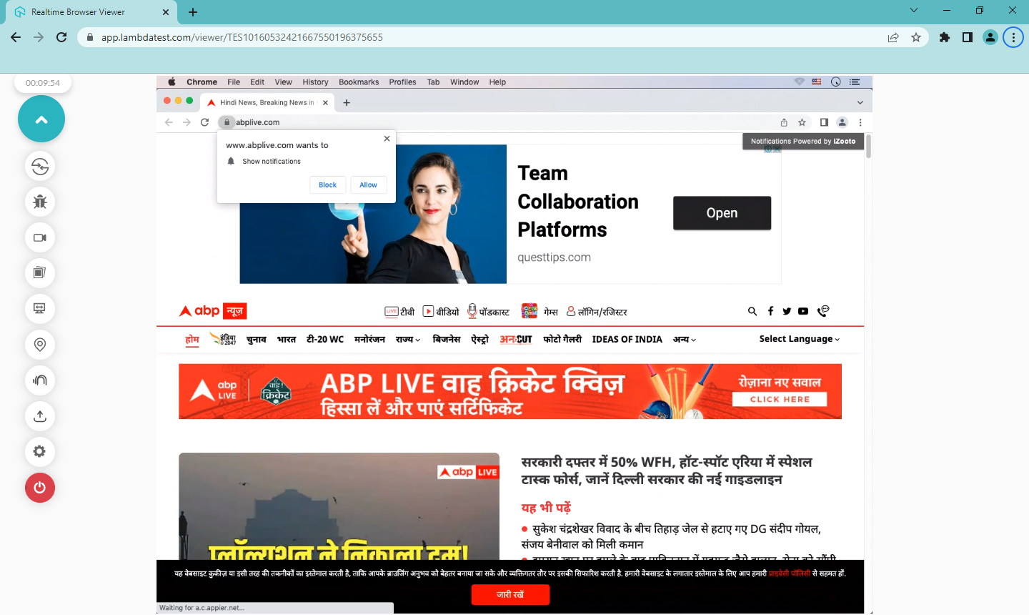

Session 2:

Device - Desktop

Browser – Brave (version 1.43)

OS – MacOS Mojave

Resolution – 1280 X 960

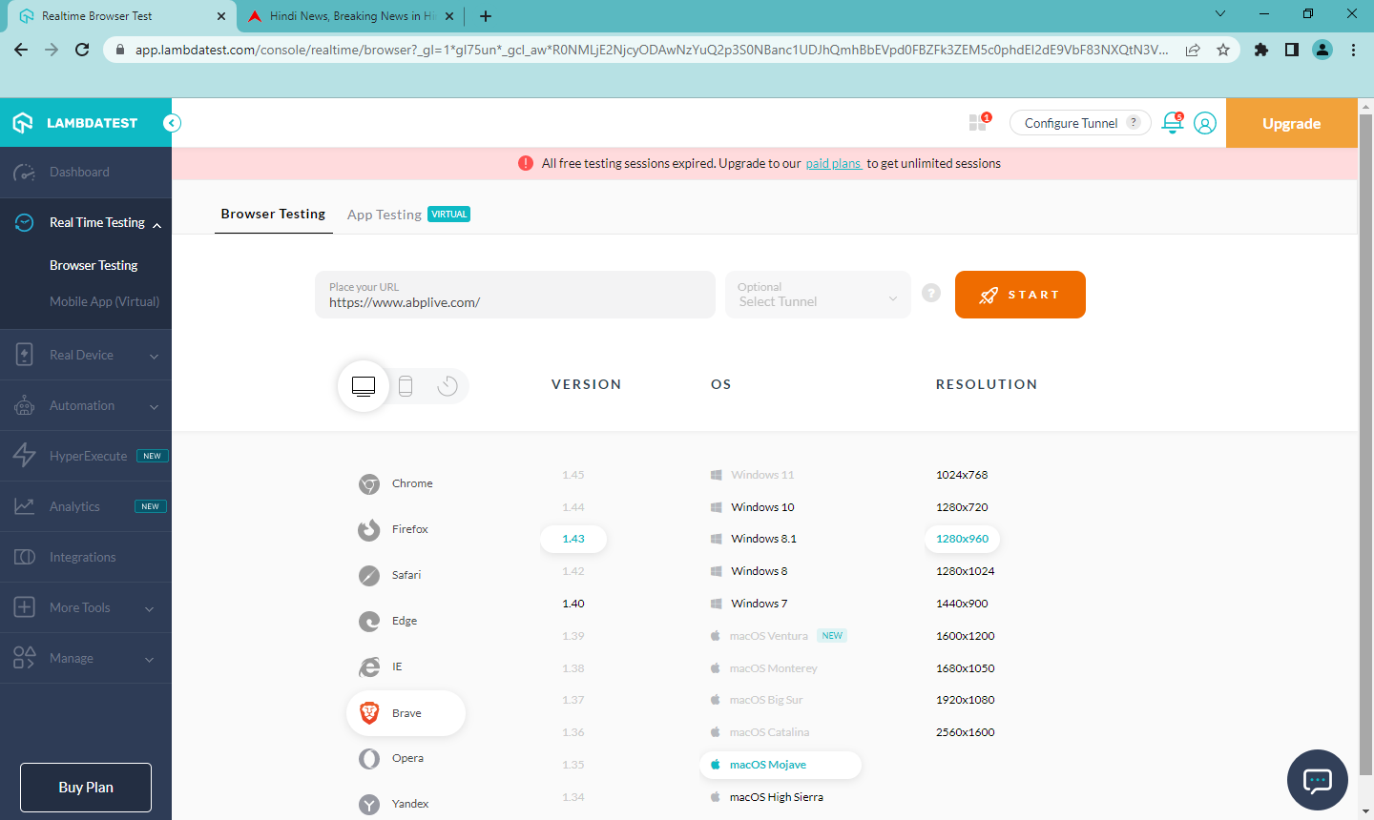

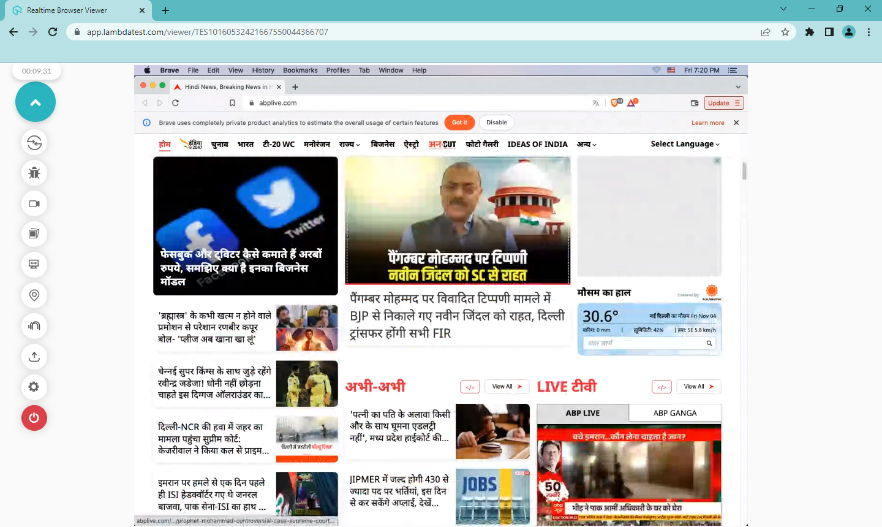

Session 3:

Device - Desktop

Browser – Firefox (version 104)

OS – Windows 7

Resolution – 1366 X 768

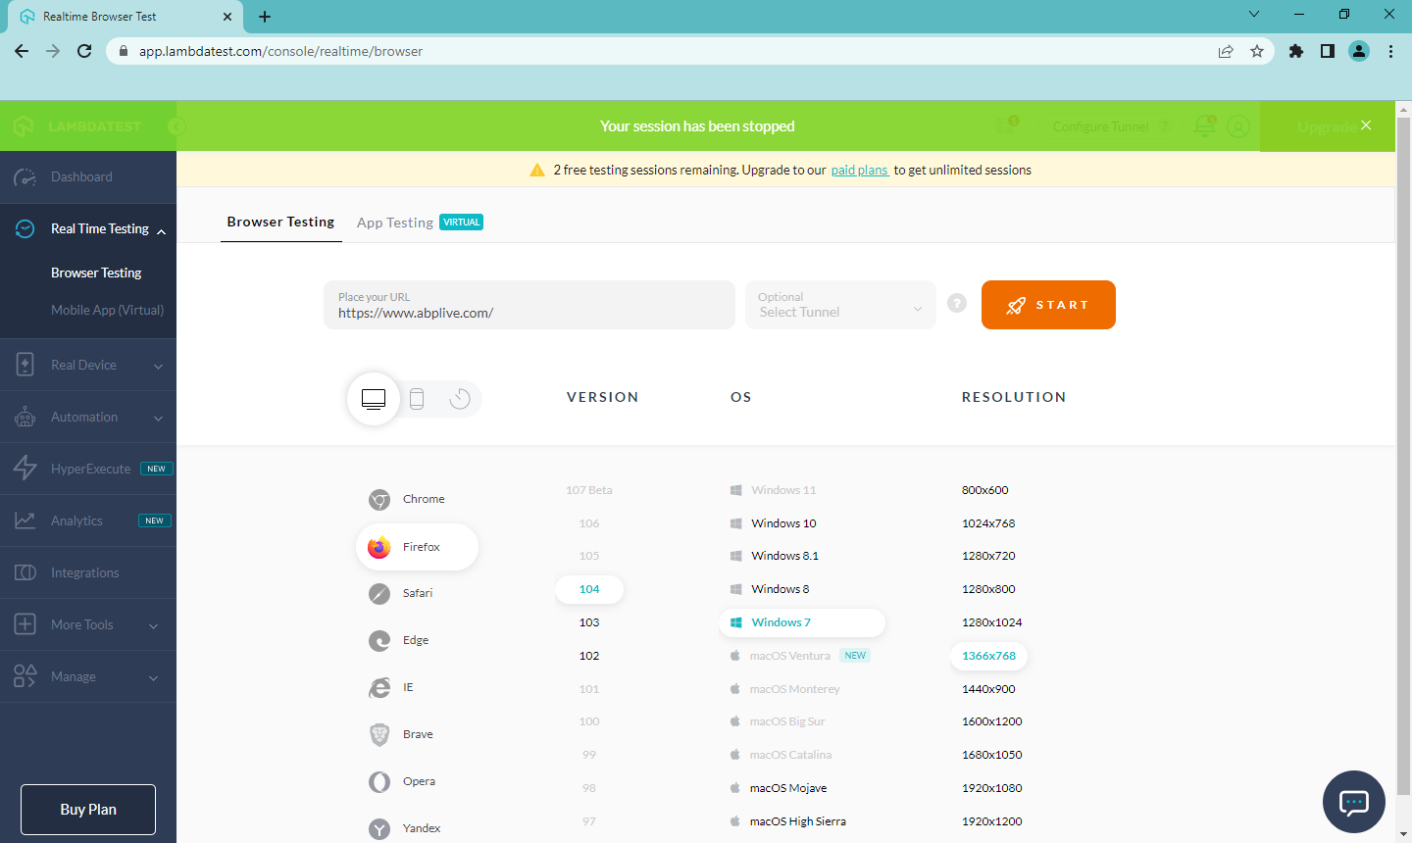

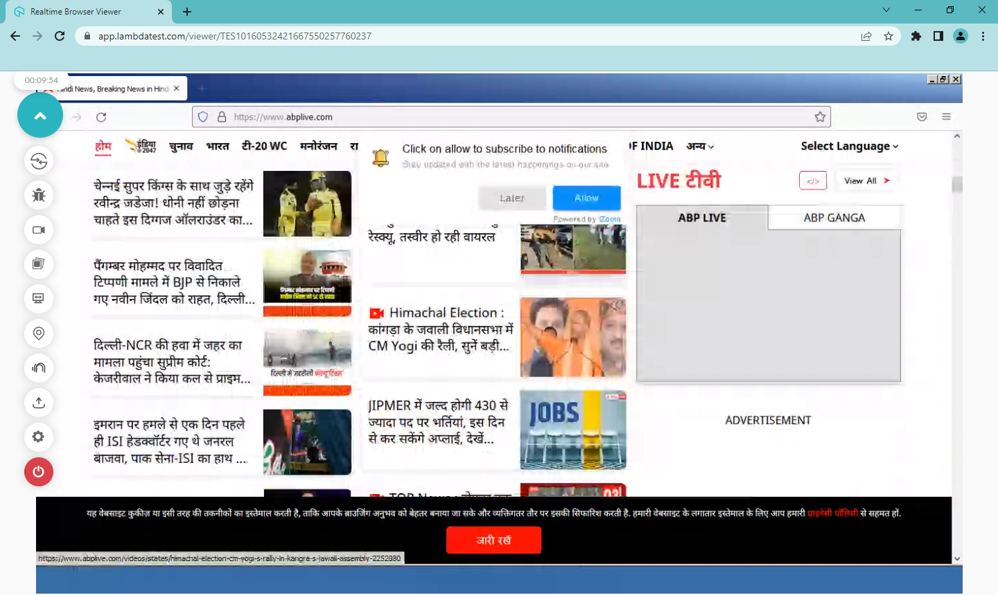

Session 4:

Device - Desktop

Browser – Safari (version 11)

OS – macOS High Sierra

Resolution – 1280 X 960

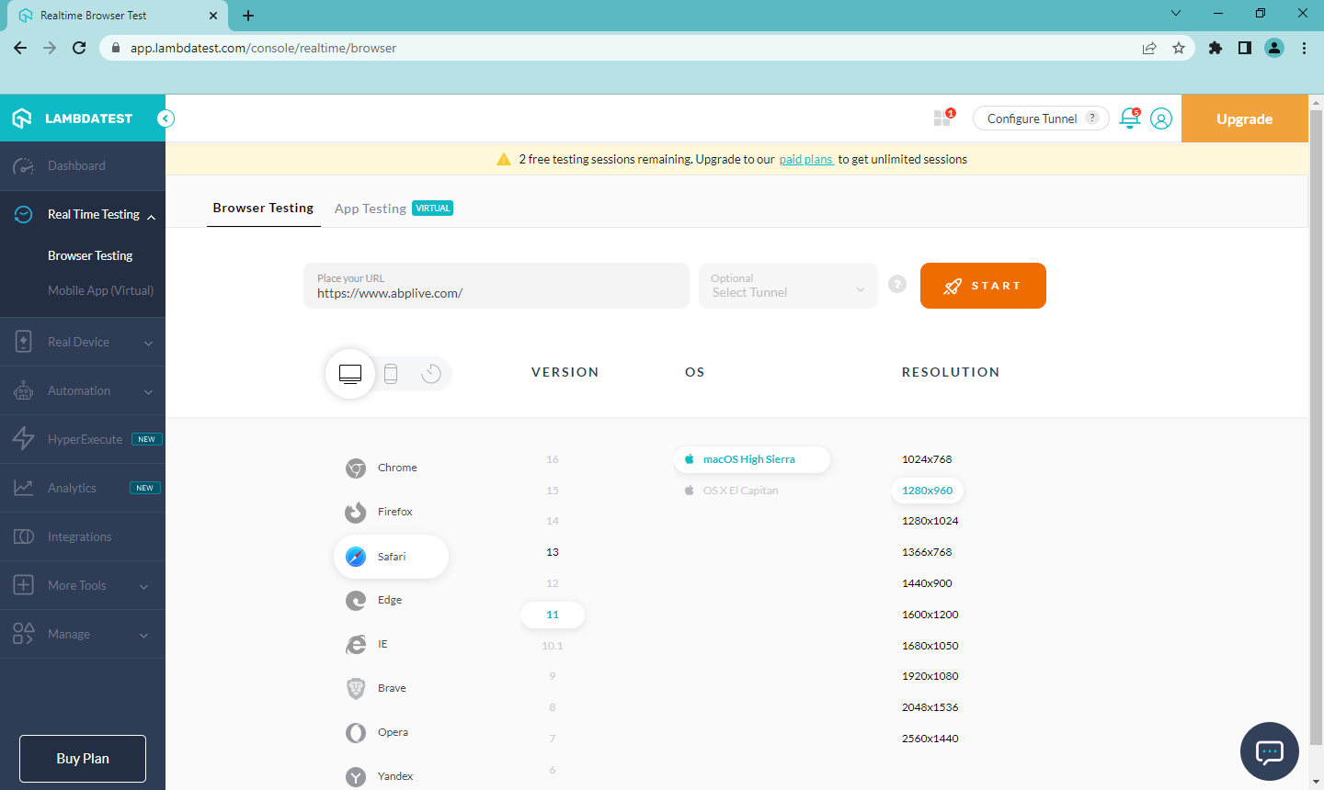

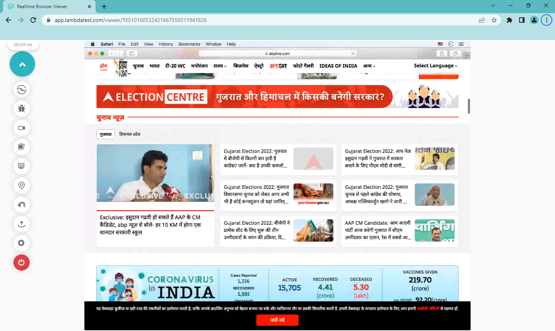

Session 5:

Device - Mobile

Brand - OnePlus

Device – OnePlus 8 (Version 10.0)

Browser – Google Chrome

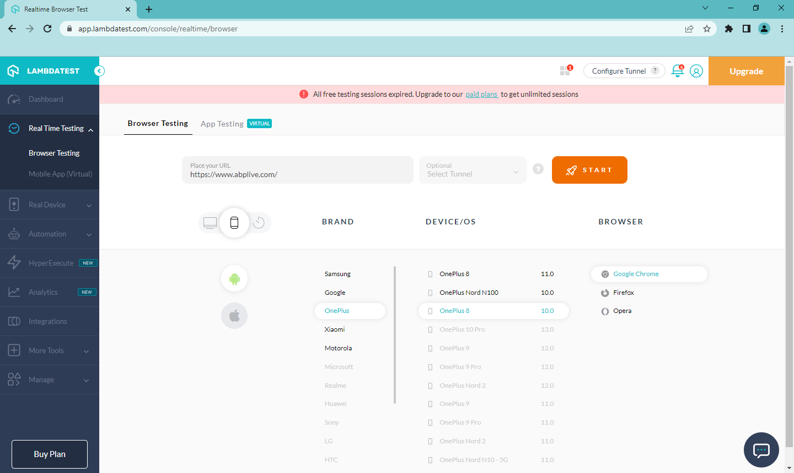

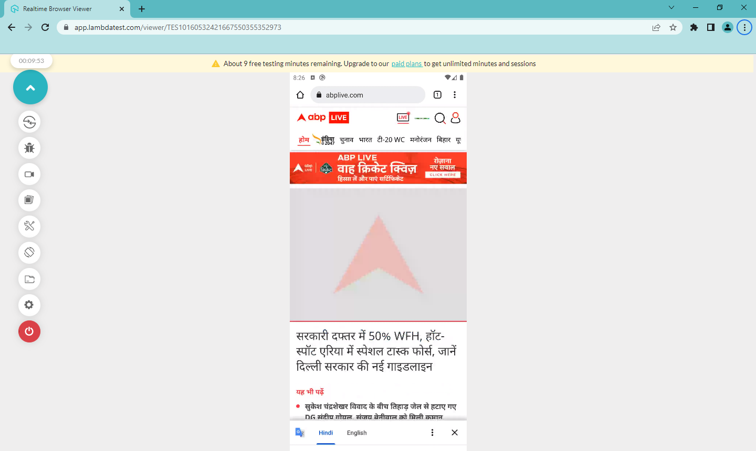

**Three features of LambdaTest:**

1. **Responsiveness – Conducting Visual UI testing of website on different devices**

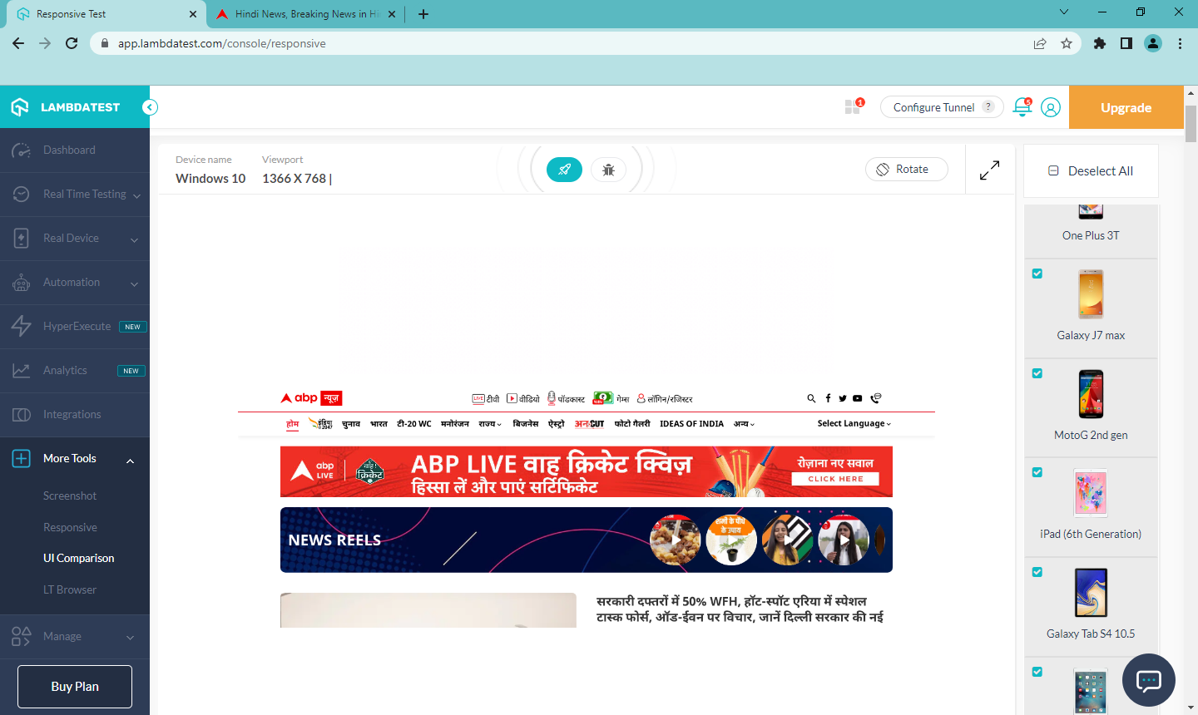

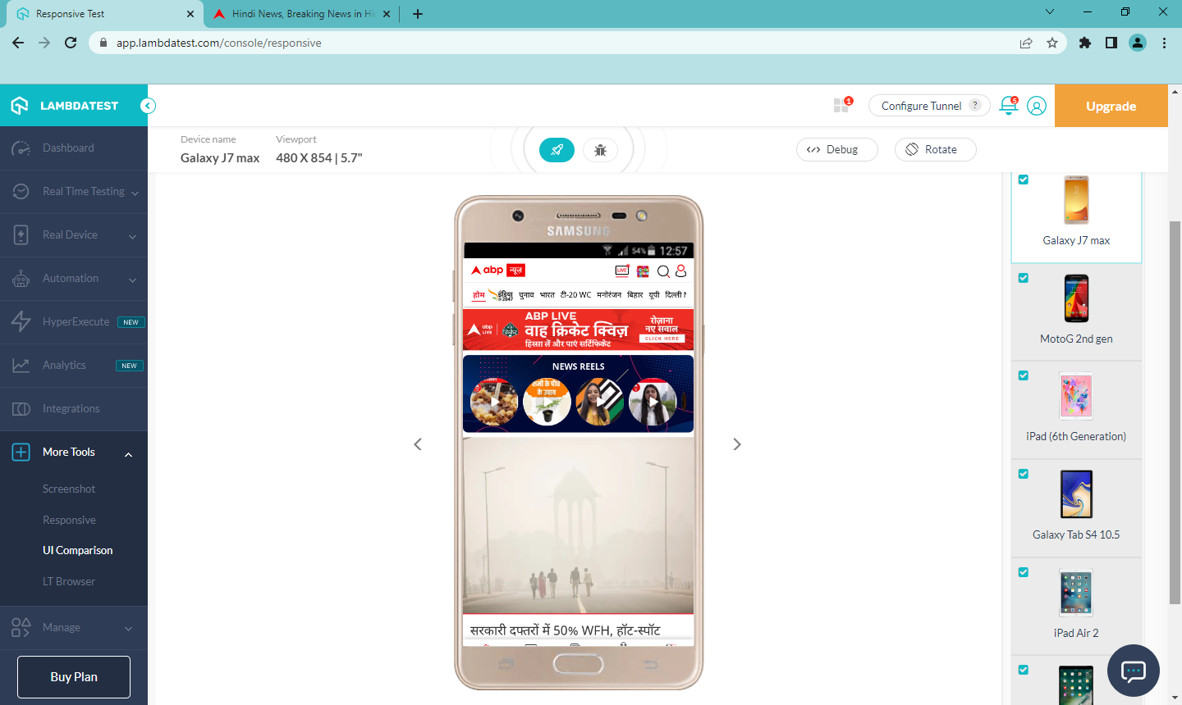

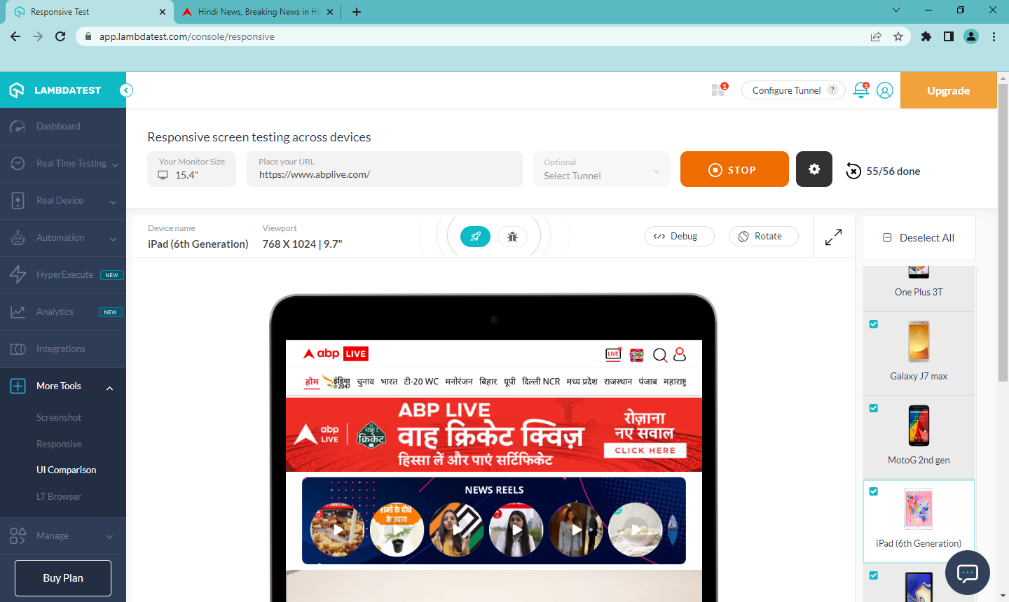

1. **Screenshots**

It helps us take automated full page screenshots on Windows Machine running real operating systems in a click. After selecting various browsers, versions and operating systems we get screenshots of the website to be tested, we can mark bugs if any.

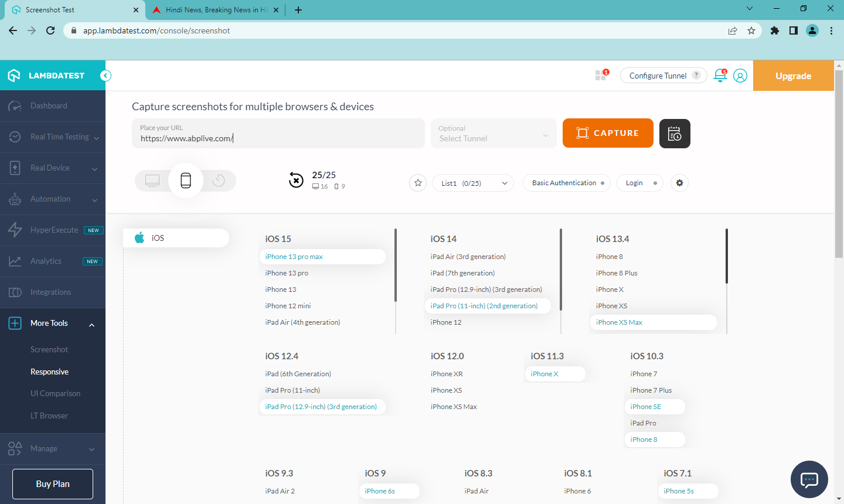

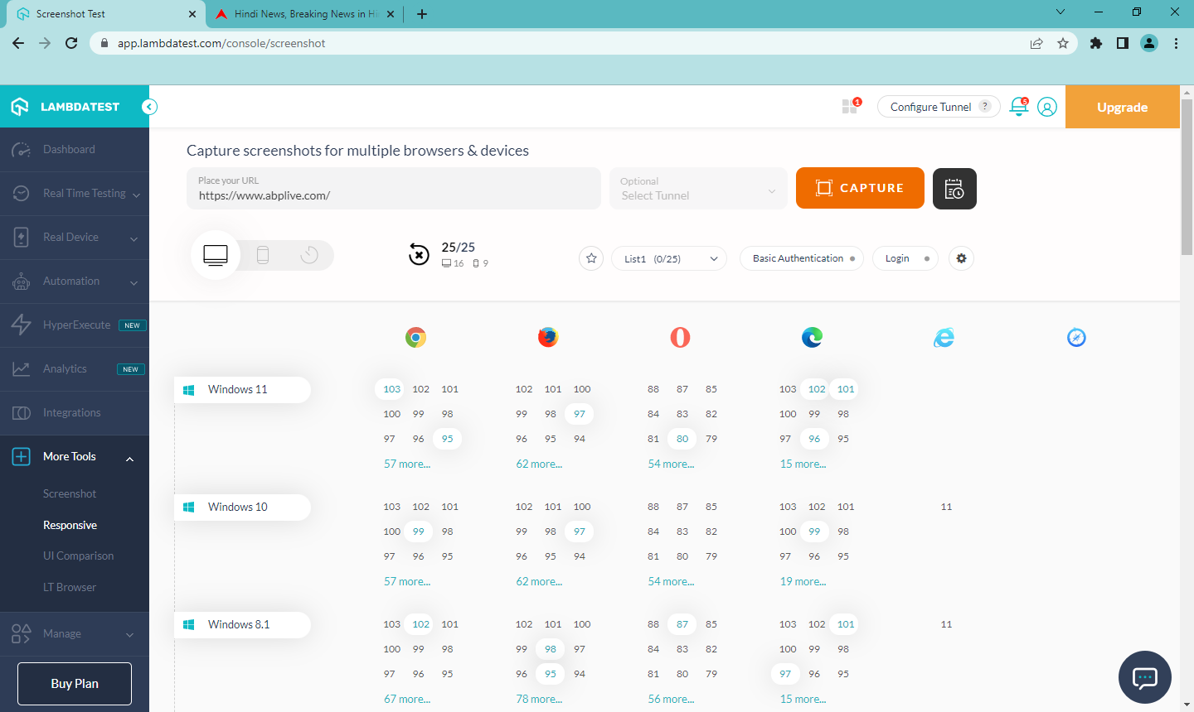

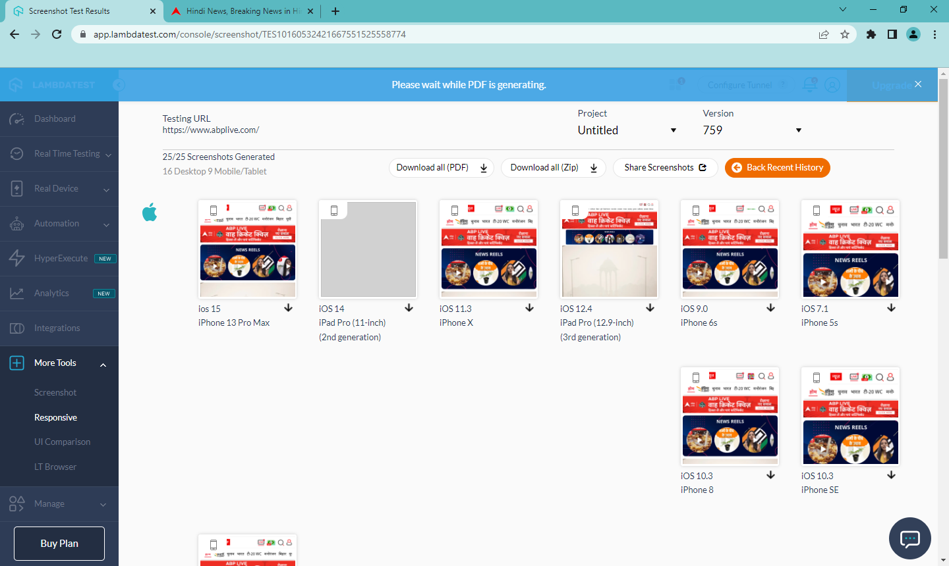

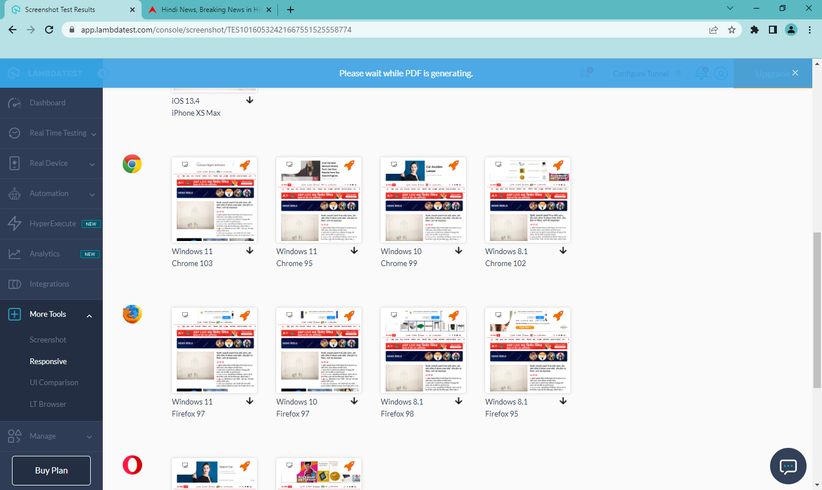

1. **Test Logs**

Test Logs is a library where you can find logs of all cross browser testing performed by us on LambdaTest. Selecting any tests will give us the details of the test, we can also move a test from one project to another.

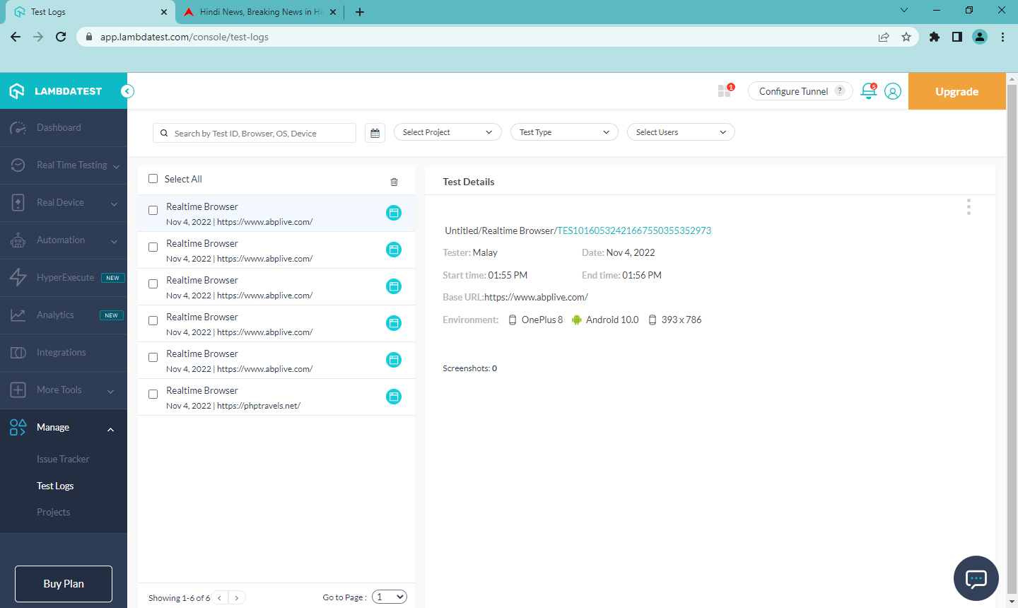



**Questions:**

# Explain backward and forward Compatibility Testing.

**FORWARD COMPATIBILITY TESTING:**

To verify and test developed software or hardware to see if it is compatible with future versions of other platforms or not is known as forward compatibility. Because all of the dynamics of the future compatible platform(s) are not always known, forward compatibility testing is a little bit harder to test than backward compatibility.

**BACKWARD COMPATIBILITY TESTING:**

To verify if a developed software or hardware product is compatible with older platforms or not is known as backward compatibility. In this case, all of the dynamics of the potentially compatible platform are known, so backward compatibility testing is much more predictable than forward compatibility testing.

# Difference between Sauce Lab Testing and Lambda Testing

**LambdaTest:**

1. Cost-effective, good integration , and parallel testing leads to good performance.

2. It supports cross browser testing on different devices such as Desktop, Mobile Devices, and

many more.

3. Initial setup and deployment in LambdaTest is straightforward and fast.

4. LambdaTest users say it integrates well with other platforms but lacks analytics.

5. Several LambdaTest mention they would like to have tools for real device testing.

6. It is a budget friendly solution.

**SauceLabs:**

1. Metrics about testing across the company are easily accessible, and it&#39;s easy to integrate.

2. In this case, all of the dynamics of the potentially compatible platform are known, so backward

compatibility testing is much more predictable than forward compatibility testing.

3. Initial setup and deployment is easy and fast.

4. Sauce Labs users like its dashboard and say it is scalable and flexible.

5. A few users mention that sometimes the speed of interaction with devices is a bit slow.

6. It’s a bit expensive for enterprise purpose.



**Outcomes:** Apply recent automation tools for testing software.



# Conclusion: (Conclusion to be based on outcomes)

**Grade: AA / AB / BB / BC / CC / CD /DD Signature of faculty in-charge with date**



# Reference Websites:

* 1. https://app.crossbrowsertesting.com
  2. <https://www.softwaretestinghelp.com/how-is-cross-browser-testing-performed/>
  3. <https://endtest.io/tests>
  4. https:/[/www.lambdatest.com/](http://www.lambdatest.com/)
  5. <https://experitest.com>
  6. <https://www.abplive.com/> - The website which is used in the above experiment.